

Items highlighted in yellow are tasks for you to complete
Items in Blue are help tips

MWP 113 Using Macros

First decide what your macro is going to perform.

Let us create a macro to automatically create a standard header and footer.

1. Choose Tools, Macro, Record New Macro…
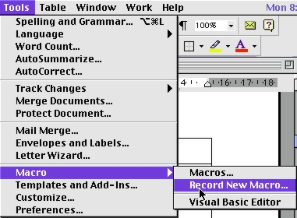


Ready for a break!

Just ask?

We will get a Record Macro box so all we need to do now is label our macro, lets call it header and header footer recorded by …

We don't need to assign toolbars or Keyboard keys yet so enter the above information then click O.K.
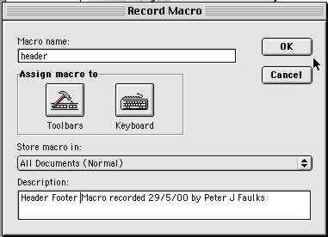

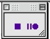

We now get the record the recording box, our cursor changes
To an arrow and we so we can now use our key strokes to
record our macro. THE MACRO HAS STARTED

Go to View Headers and Footers, Select the font Sand, 14pt red and type PIP Training, tab (press the TAB button) "Word Advanced" tab "your name".

Click on the switch to Footer on the header footer toolbar type Page space bar and the center tab then insert page number from the page number icon.

Close the record macro by clicking on the Stop Recording switch

We now have a macro to put a header and footer on our document.

Test the macro and if it works well we can now assign key stroke to the macro.

From the Tools menu go to Customise and we will select keyboard.
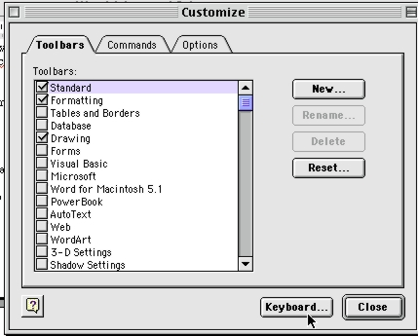

Once we have clicked Keyboard… We will need to go to Categories and Macros

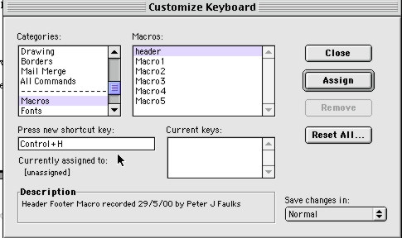

We can now assign the shortcut key Control+ H as our assigned shortcut.
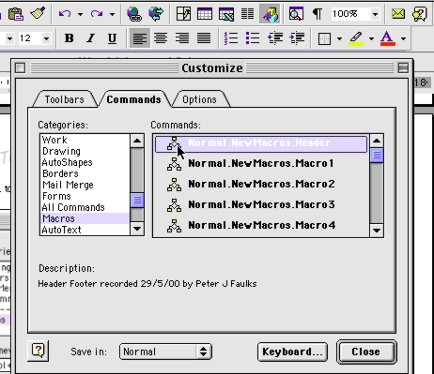
Copy to toolbar

Open View Toolbars, Customise

And click on Commands track down to Macros and select the header macro

Then drag the macro to the toolbar.

Ensure that save in,
is set to the current document.

Our macro now resides on our toolbar

Once you have enabled a macro and applied it to your document, you will be warned that opening that document contains Macros and you can disable or enable them.

